Methodological Exercises Outline
Week 10: Research Methods
- CONTENT ANALYSIS:
Step1: Research question-What were the major influences on Van Gogh’s art? I hypothesize that the events of his own life were the central influences on Van Gogh’s art. Good!
Step 2: Key words: list of paintings by Van Gogh, life influences, most famous paintings
Step 3: Since Van Gogh has over 900 paintings, I just chose 20 of his most famous ones to keep it short as suggested.(Please see excel worksheet) GOOD WORK – and I’m glad you didn’t use all 900!!!
Step 4: After researching Van Gogh’s painting, I found that all of Van Gogh’s paintings had some influence from his life. Some were very obvious and others were subtle. By choosing his 20 most famous paintings, and all had influences of his life, this proves that my hypothesis was correct.
5/5 well done.
- DISCOURSE ANALYSIS:
Research question-What were the major influences on Van Gogh’s art? What I found was most interesting is that not only did his artwork reflect his life but it also showed his emotional state which was very depressed. Almost all his paintings reflect a sad and depressing feeling.
To explain this, I used 5 of his famous paintings to discuss to prove my point.
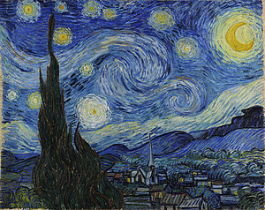
Starry Night- In this piece, Van Gogh paints a single Cypress tree in the foreground of the painting. Cypress trees like the one portrayed are associated with death because they were planted in graveyards a lot, and Van Gogh described them as occupying his thoughts a lot. The night sky, and stars in particular, hold a personal symbolism with Van Gogh because he seems to have seen them as a religious symbol and associated them with death in some of his letters, saying we take death to reach a star. It has been suggested that the large scale of the sky shows his awareness of his own mortality; it reminds me of how big the universe is compared to humans. The sky is so alive and large compared to the tiny still town beneath it.
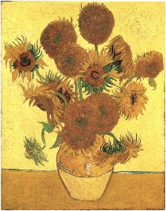
Sunflower-Van Gogh uses bright, vivid colors that bring the flowers to life. He provides a contrast to these bright tones by including dying sunflowers in the paintings. In this way, Van Gogh references the entire life cycle of the flowers.
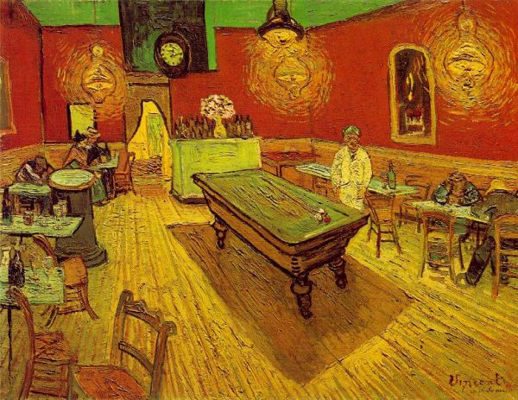
Night Café- depicts the late-night crowd at a café in Arles. He contrasts the vivid red of the walls with a bright green ceiling and a yellow floor. The ceiling lights emit an eerie yellow glow, and cause the pool table to cast a dark shadow on the floor. The overall feeling of isolation is amplified by the standing waiter, who appears to stare directly out at the viewer. During this time period, the all-night café served as a refuge for derelicts and prostitutes and, as such, Van Gogh wanted to express the underbelly of society in a visceral manner with his use of extreme color contrast and rough brush strokes.
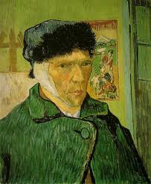
Self-portrait with Bandaged Ear- This piece is a testament to the physical effects of Van Gogh's illness as well as how close he was to finally giving up and ending his life by his own hand.

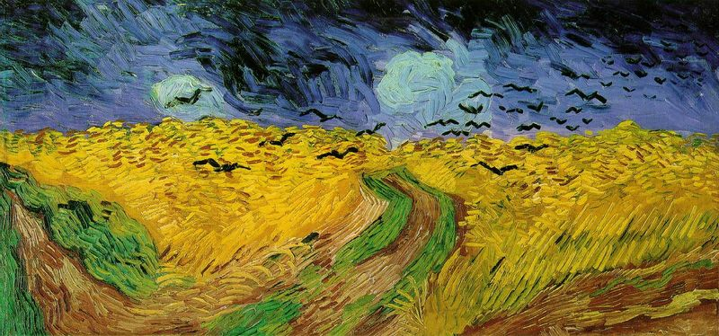
Wheatfield with Crows- The painting is, without question, turbulent and certainly conveys a sense of loneliness in the fields. The painting probably represents Van Gogh's own inner torment and loneliness as a defeated and solitary artist in his final years. The crows in the painting represent the harbingers of death. Some say this was his final painting before he shot himself.
What is the result of your ‘research’ here? Otherwise well done.
4.5/5

